**Lab Test 1**

**Total: 50 marks**

**Name: Lee Hoe Mun Programme: SE**

**NOTE and Instructions:**

1. This lab test requires two virtual machines: Ubuntu server and Ubuntu Desktop.
2. It is recommended to take a snapshot of virtual machine before you start the test or make changes.

**For each task, insert screenshot(s) to show the commands executed / content of a file which has been modified.**

**Make sure YOUR NAME is visible in the screenshot.**

**Complete all the following tasks:**

1. Create a new user in both Ubuntu server and Ubuntu Desktop with the following information.

* Username : **your_full_name**
* Default password : guess
* Home directory : /home/your_full_name

Command: **adduser leehoemun** (2 marks)

Screenshot (Server): (1 mark)

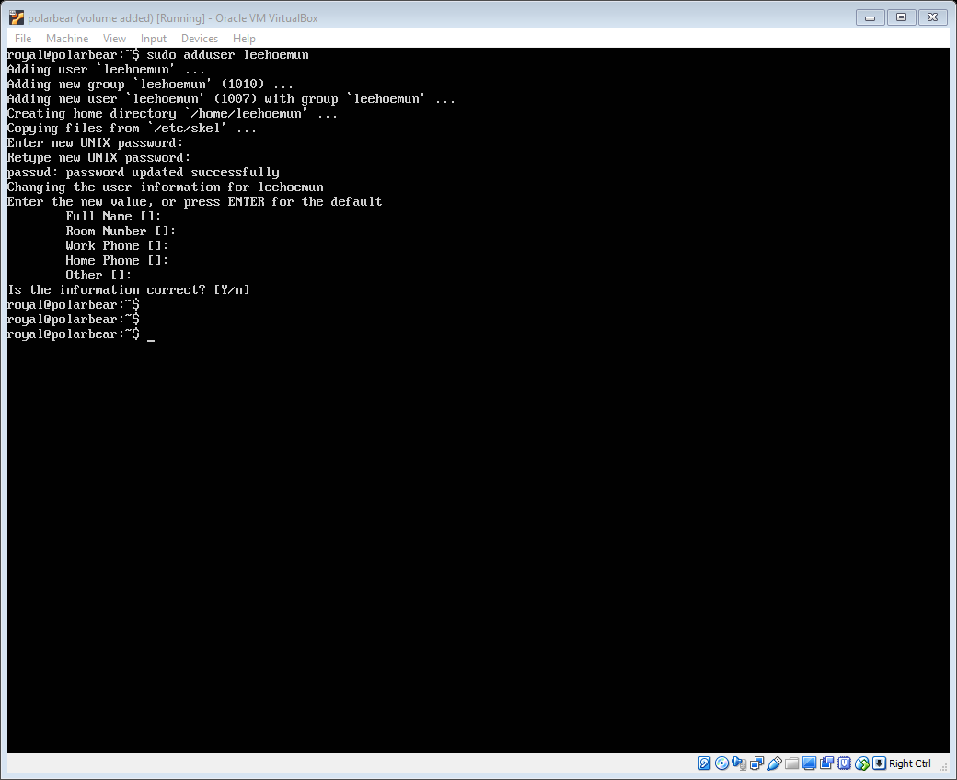

Screenshot (Desktop):

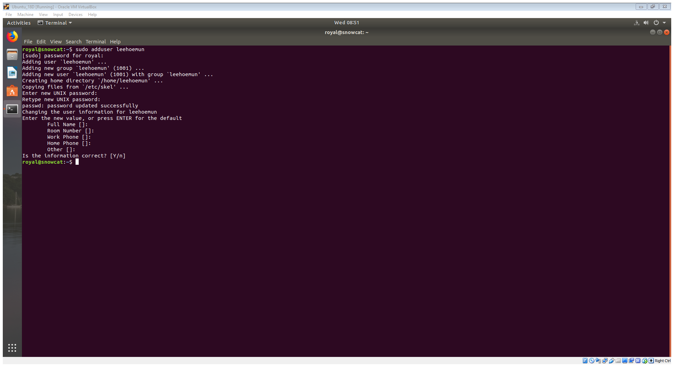 (1 mark)

1. Allow the newly created user to perform **sudo**.

Command: **usermod –aG sudo leehoemun** (2 marks)

Screenshot:

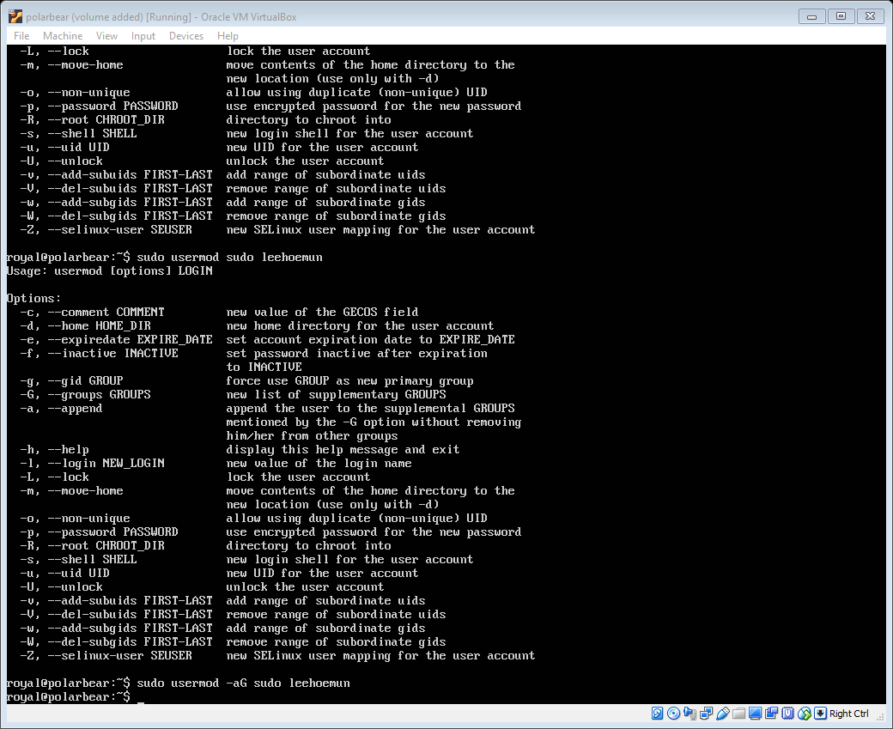 (1 mark)

1. Check if the new user has been assigned with **sudo** privilege.

Command: **sudo systemctl status apache2.service**  
(Without sudo privilege the user will not be able execute sudo command, in another word, if the user can run sudo command, it means the user has sudo privilege.) (1 mark)

Screenshot:

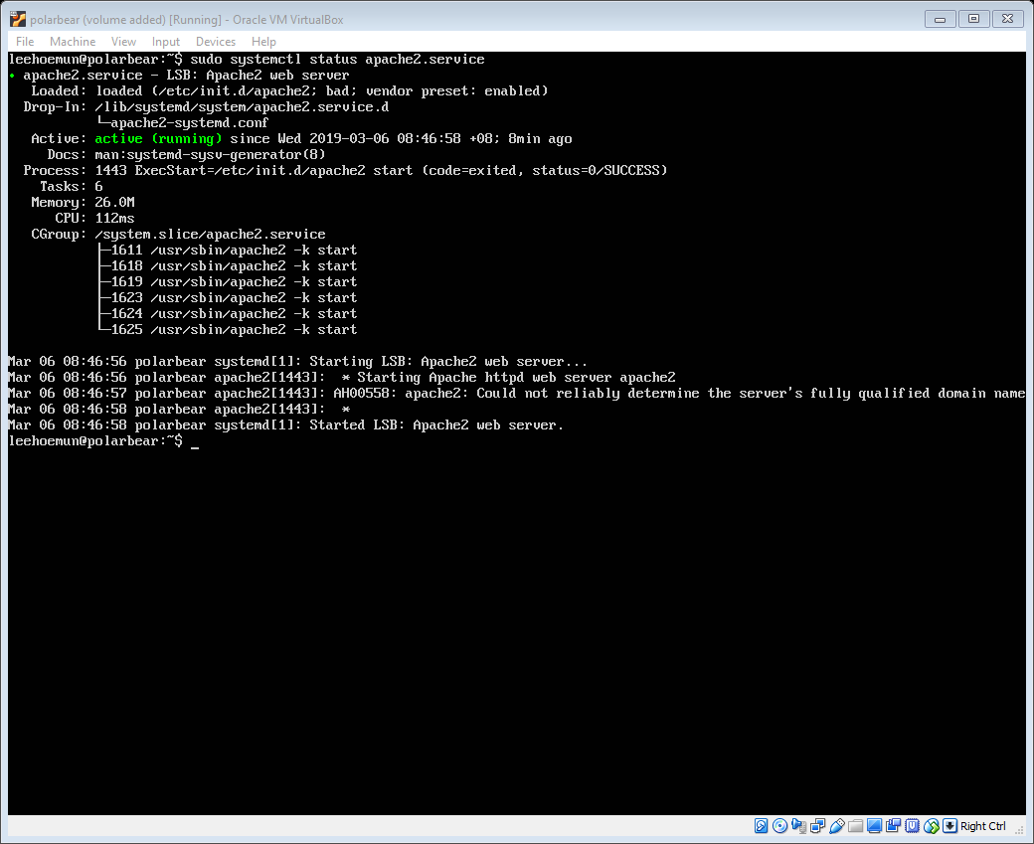 (1 mark)

# You may want to take a snapshot of Ubuntu Server before proceed.

# Log out and login again with **your_full_name**, before you proceed to the following tasks.

# Your name should appear in the prompt. Do this to both Ubuntu Server and Ubuntu Desktop.

1. Enable the **user** **quota** on root file system.

Command: **nano /etc/fstab**

Append “usrquota” to options. (1 mark)

Screenshot of file content after changes:

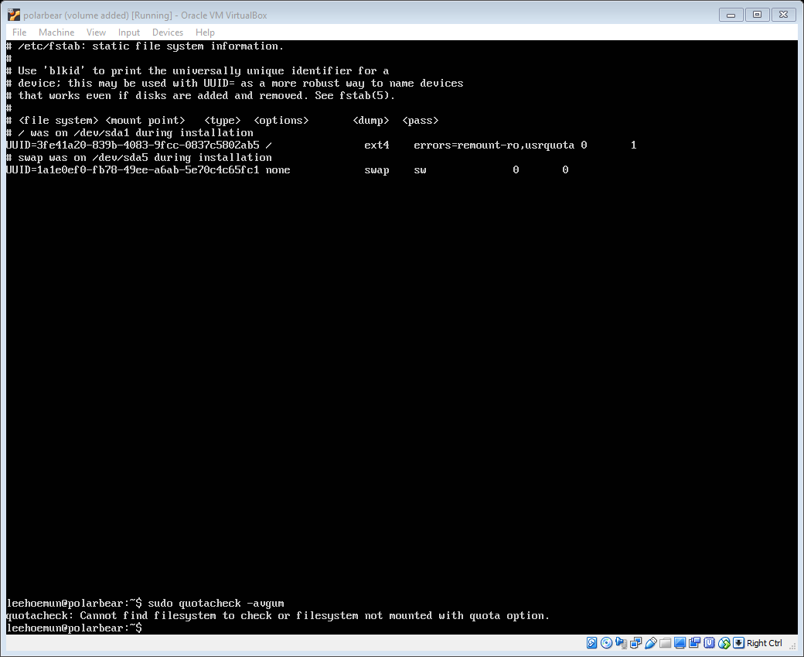 (1 mark)

1. Remount the root file system.

Command: **mount –o remount /** (1 mark)

Screenshot:

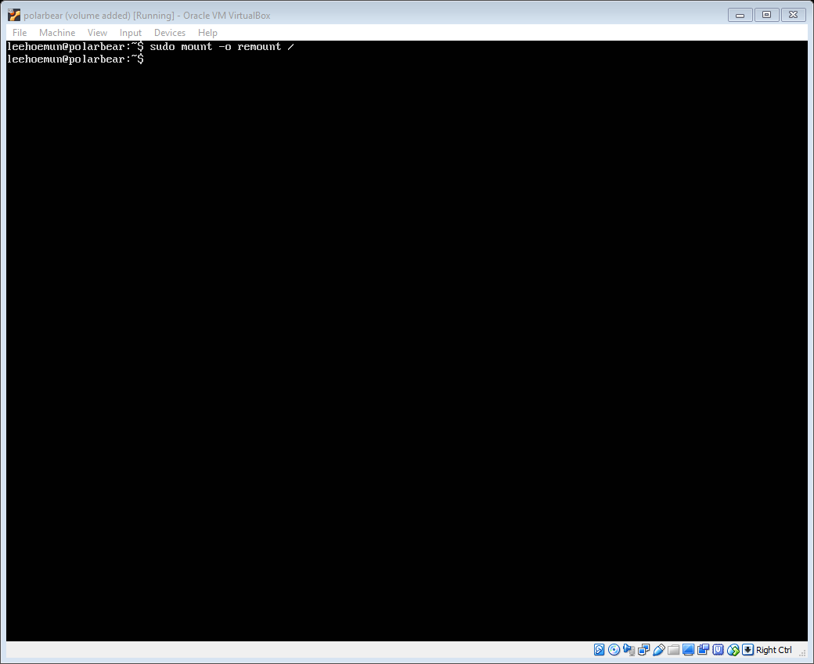 (1 mark)

1. Enable the quota support.

Command: quotacheck -avgum (2 marks)

Screenshot:

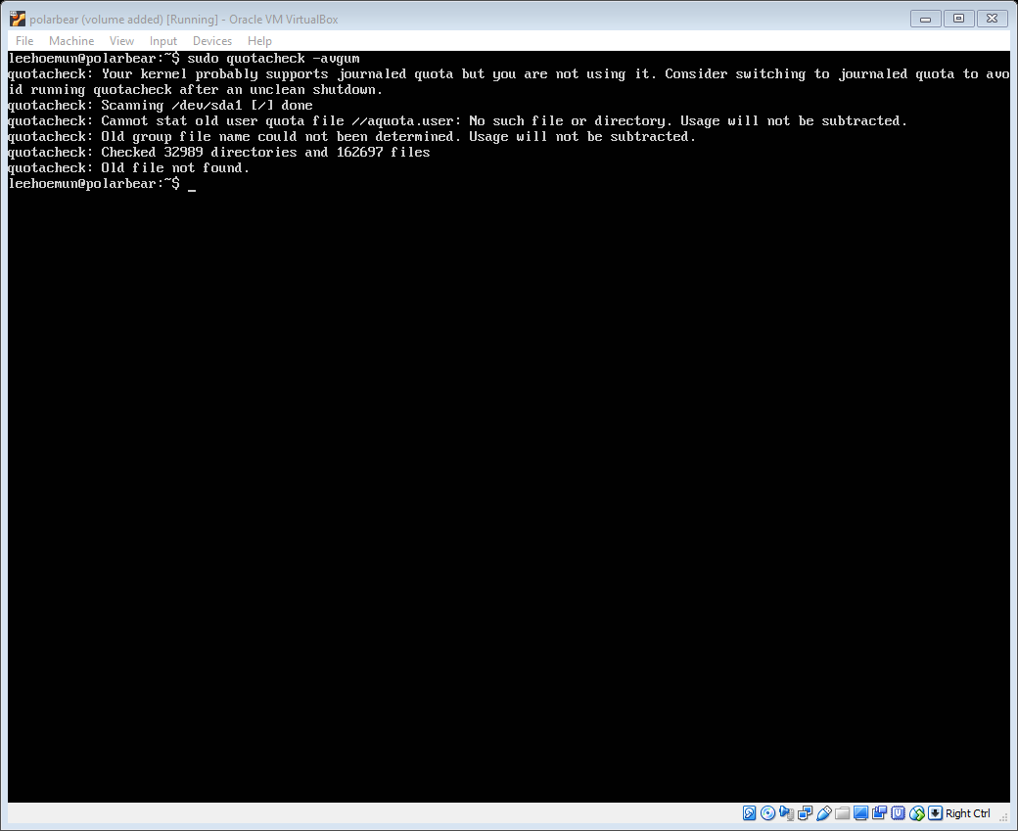 (1 mark)

1. Configure quota for yourself as follow: **soft limit 500MB**, **hard limit 550MB**

Command: **edquota –u leehoemun** (1 mark)

Screenshot: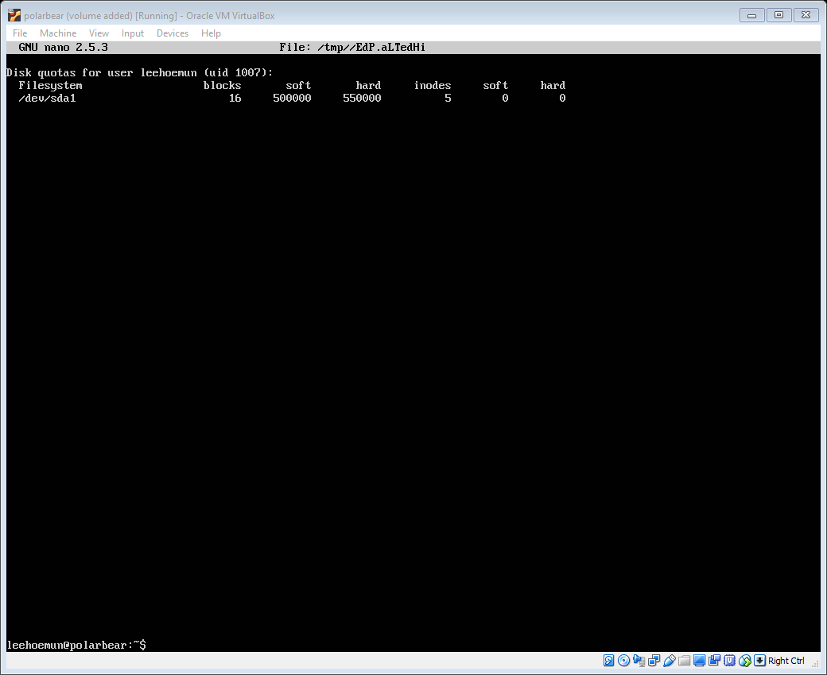 (1 mark)

1. Configure the network interface in **Ubuntu Server** and **Ubuntu Desktop** to use static IP as follow.

Ubuntu Server: 192.168.60.111

Ubuntu Desktop: 192.168.60.112

1. Command: **nano /etc/network/interfaces** (1 mark)

Configure the file accordingly.

1. Command to check / show the network interface available: **ifconfig -s** (1 mark)

Screenshot:

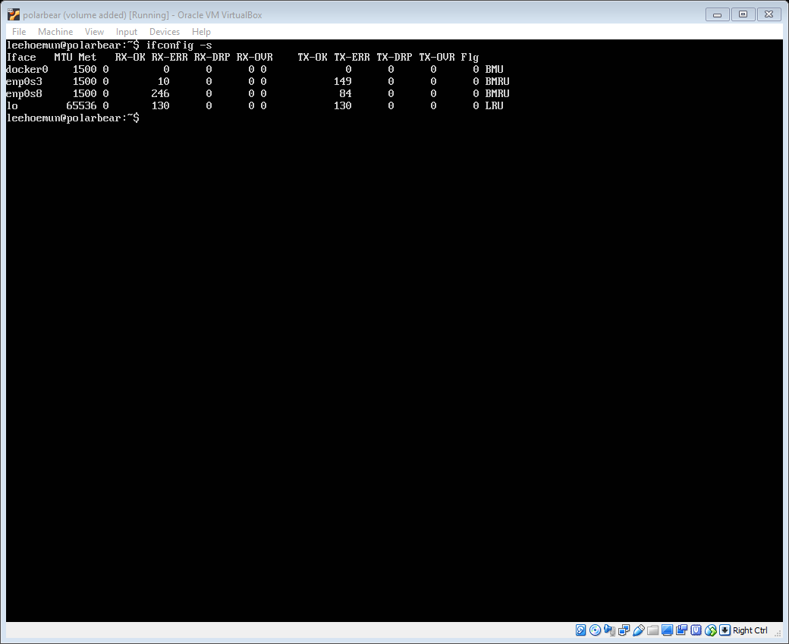 (1 mark)

1. Modify the configuration file to apply the static IP and insert the screenshot of the **file content with the static IP configuration**.

Screenshot (Server): 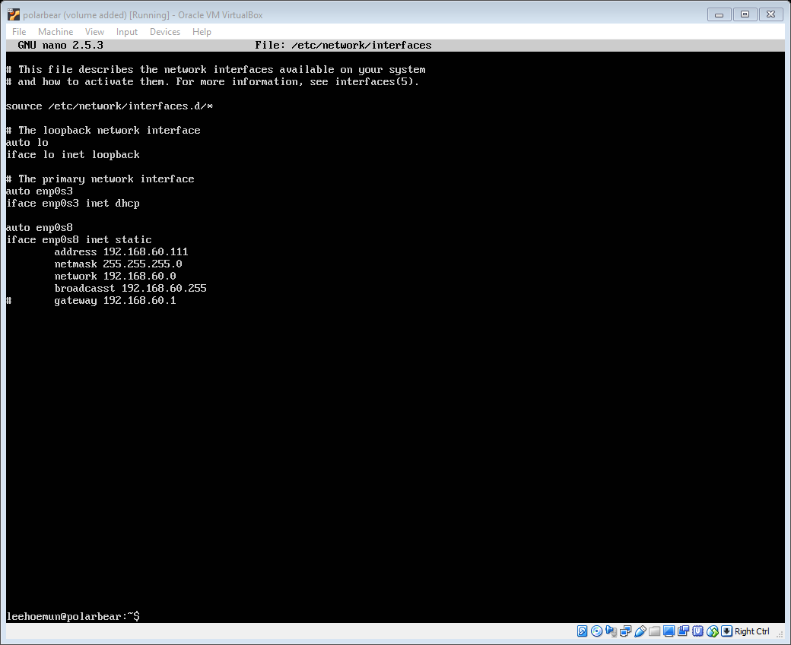 (2 marks)

Screenshot (Desktop): With GUI, we don’t have to edit the file manually.

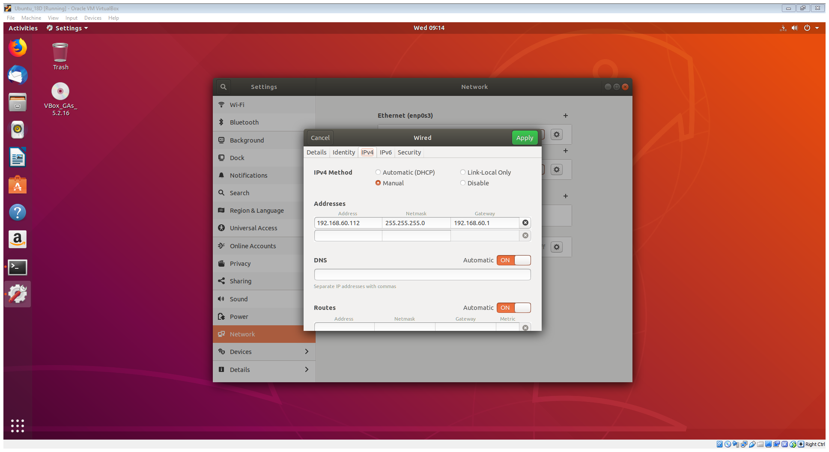

(2 marks)

1. Make the new configuration of network interface takes effect.

Command: **systemctl restart networking.service** (2 marks)

Screenshot (Server):

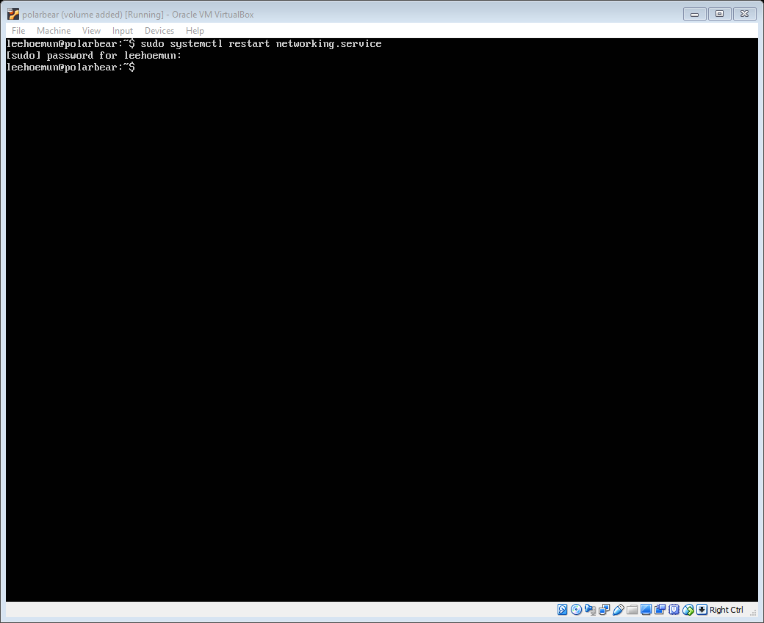 (1 mark)

Screenshot (Desktop):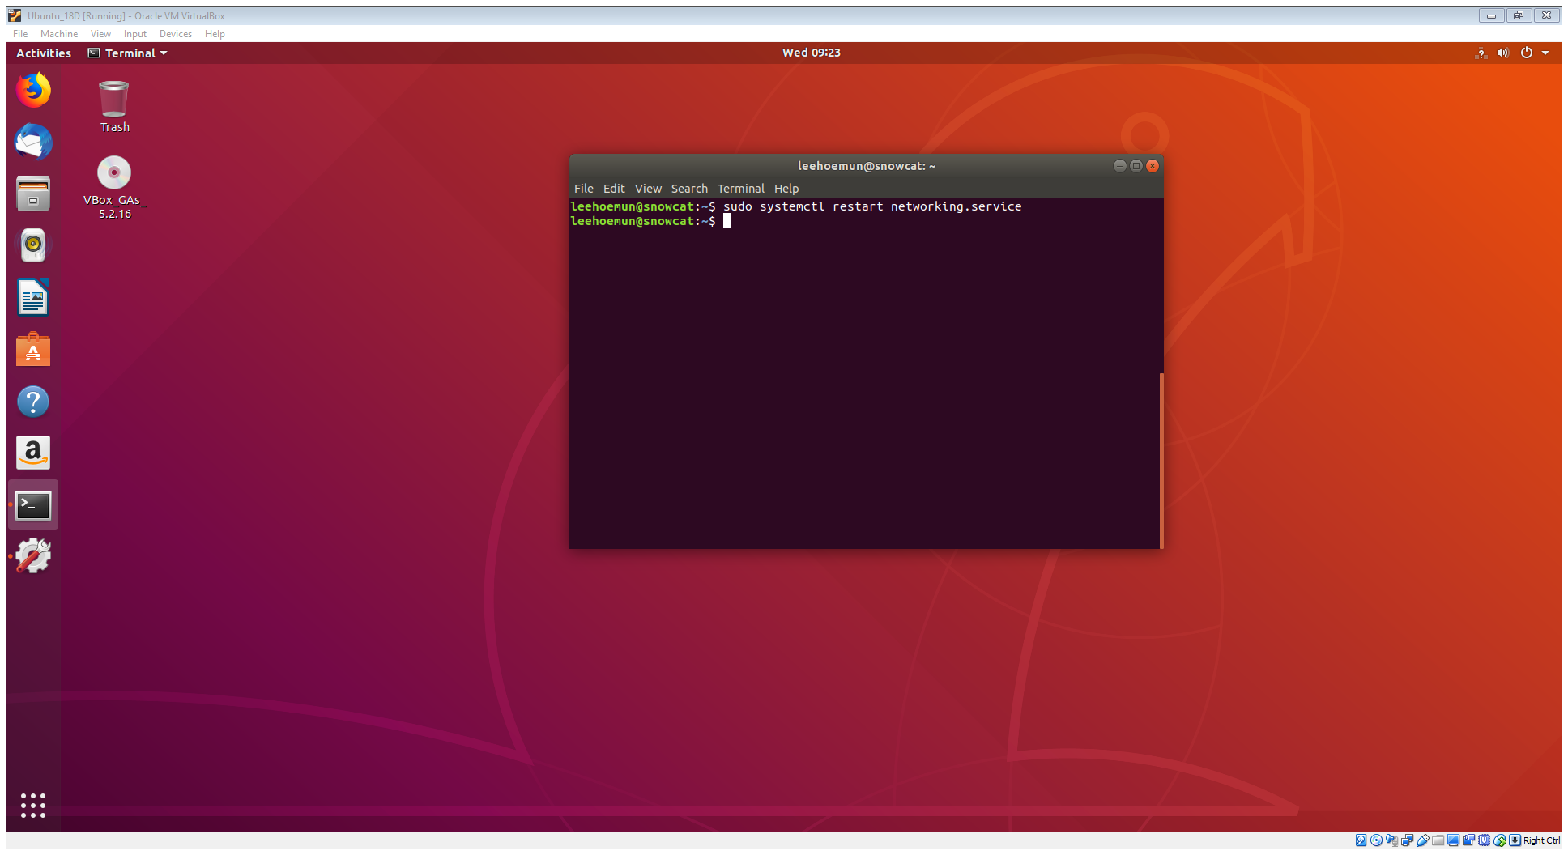 (1 mark)

1. Check if the static IP has been applied.

Command: **ifconfig**

(1 mark)

Screenshot (Server): 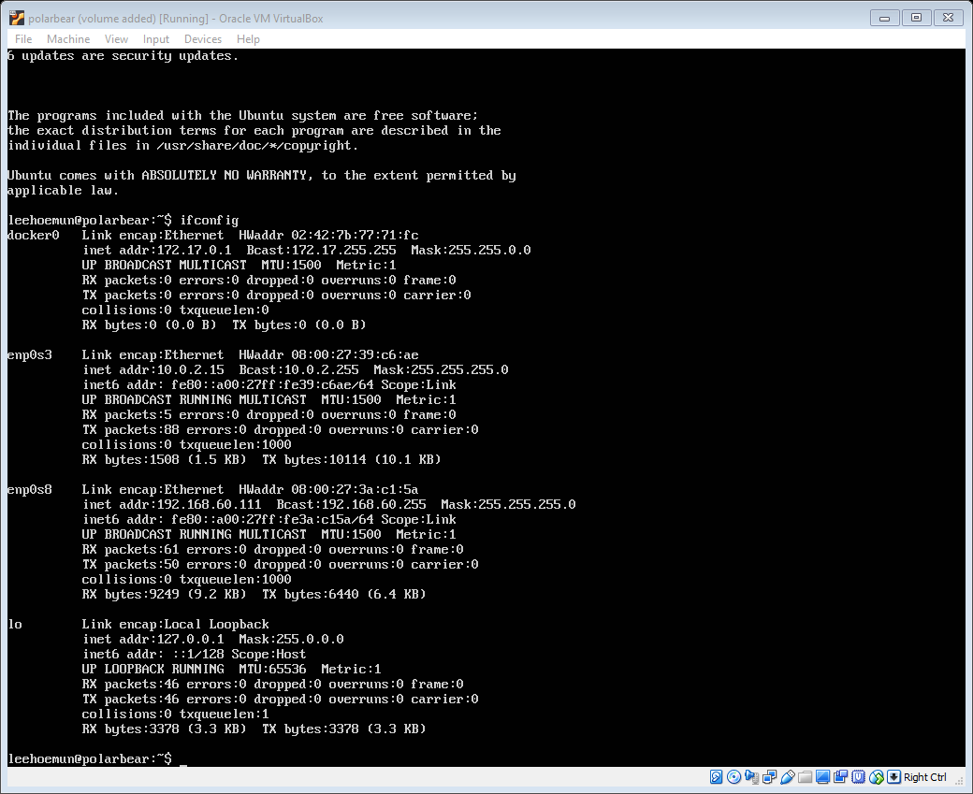 (1 mark)

Screenshot (Desktop): 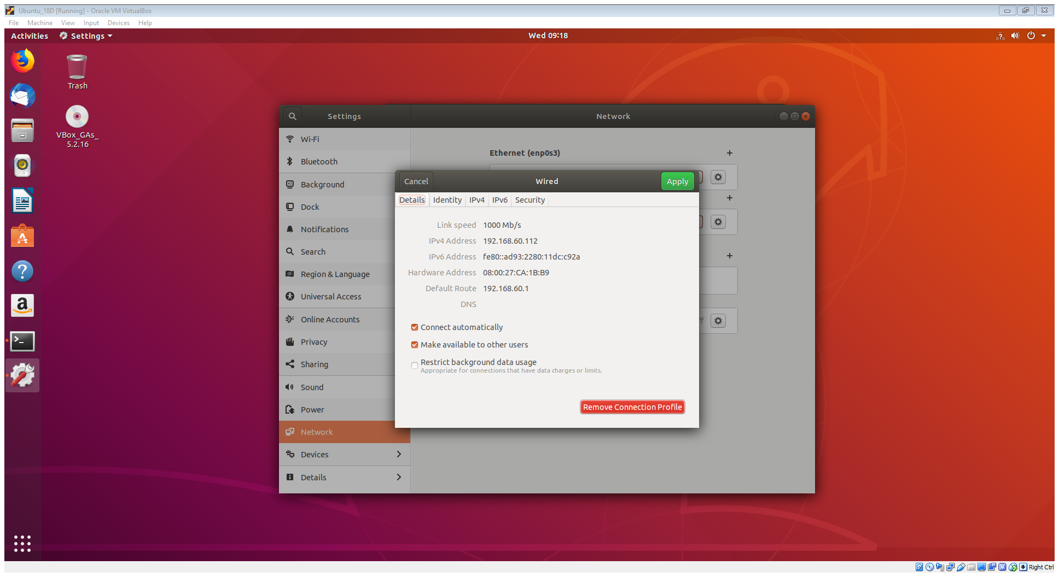 (1 mark)

1. Check if Ubuntu Desktop can reach Ubuntu Server.

Command: **ping 192.168.60.111** (1 mark)

Screenshot:

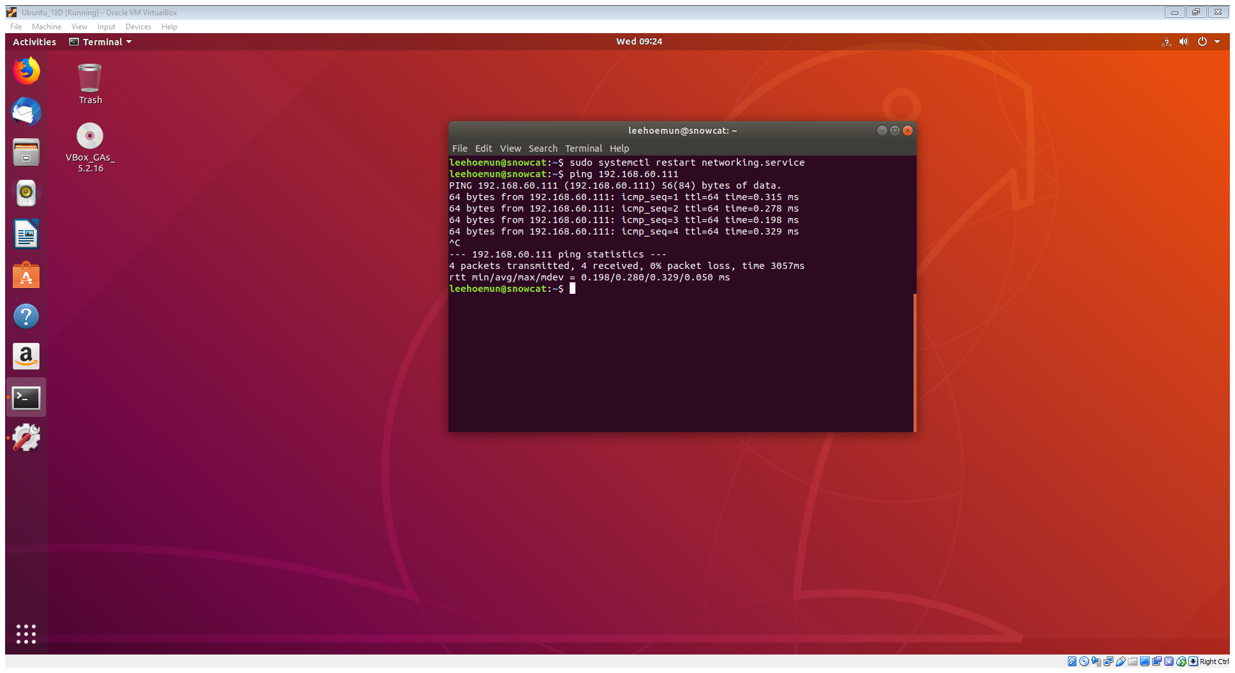 (1 mark)

1. Check if the **ssh** service is running in the server.

Command: **systemctl status ssh.service** (1 mark)

Screenshot:

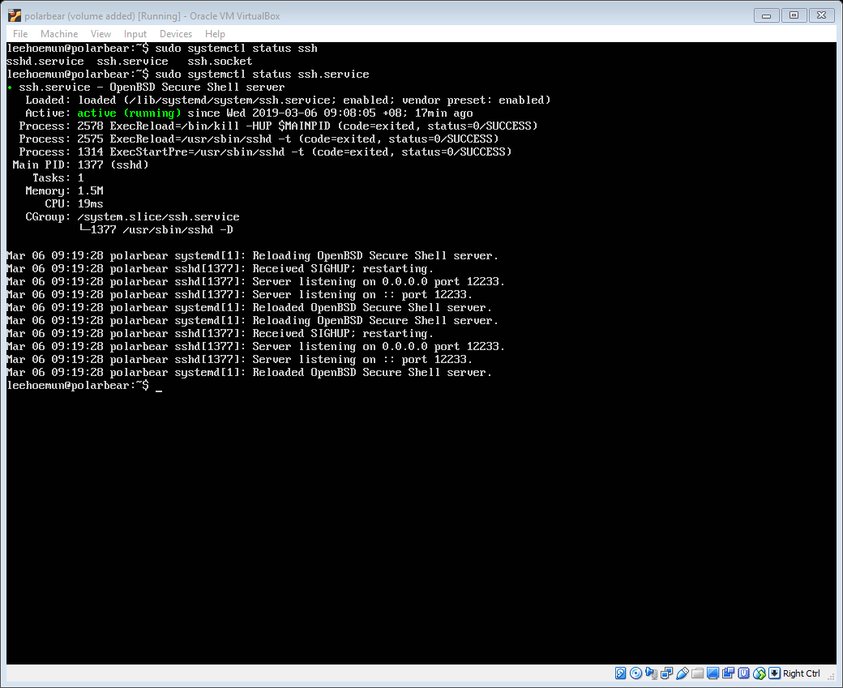 (1 mark)

1. Connect to server from Ubuntu Desktop using ssh.

Command: **ssh –p 12233 192.168.60.111**

*The port number has been configured to 12233 before I make any changes to it. (1 mark)

Screenshot:

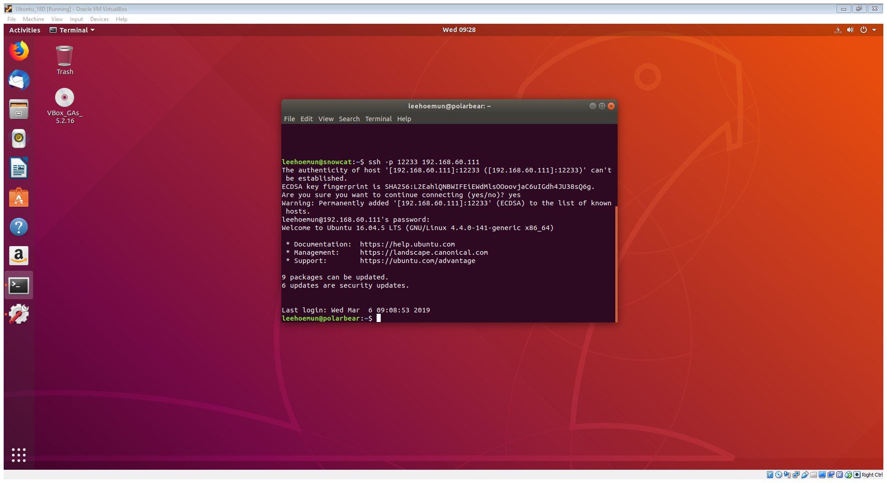 (1 mark)

1. Generate a pair of public / private keys in Ubuntu Desktop.

Command: **ssh-keygen** (1 mark)

Screenshot:

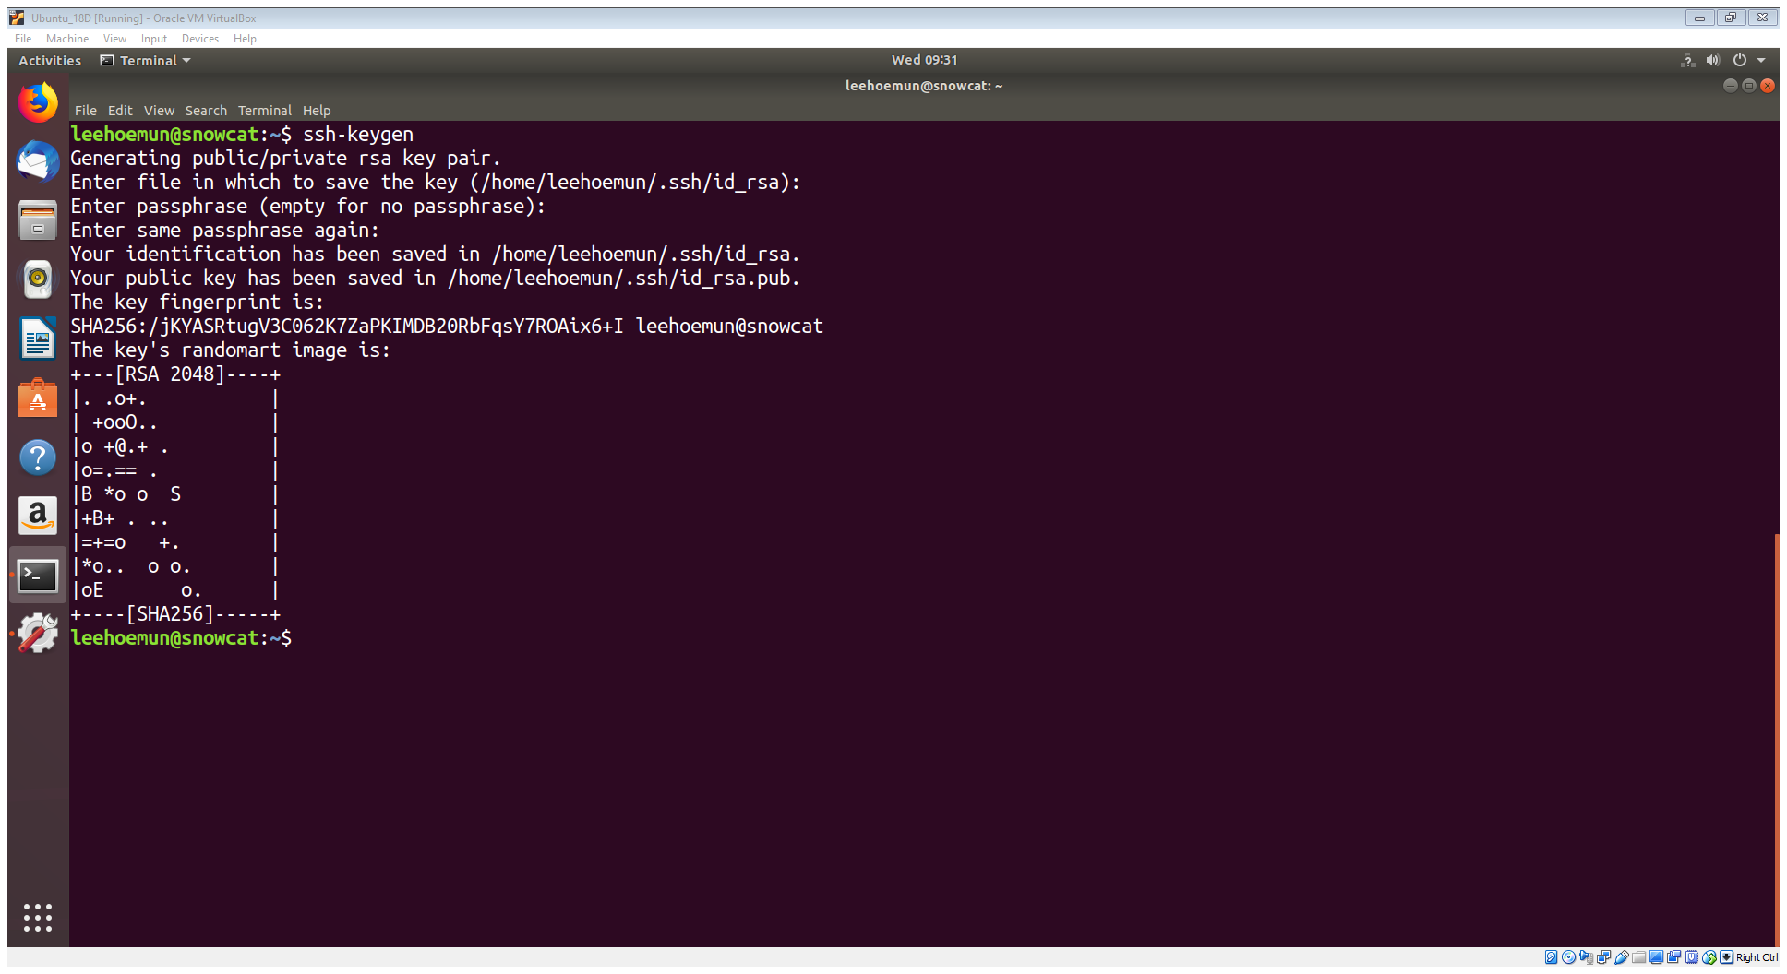

(1 mark)

1. Copy the public key to Ubuntu Server.

Command: ssh-copy-id –i ~/.ssh/id_rsa.pub –p 12233 192.168.60.111 (2 marks)

Screenshot:

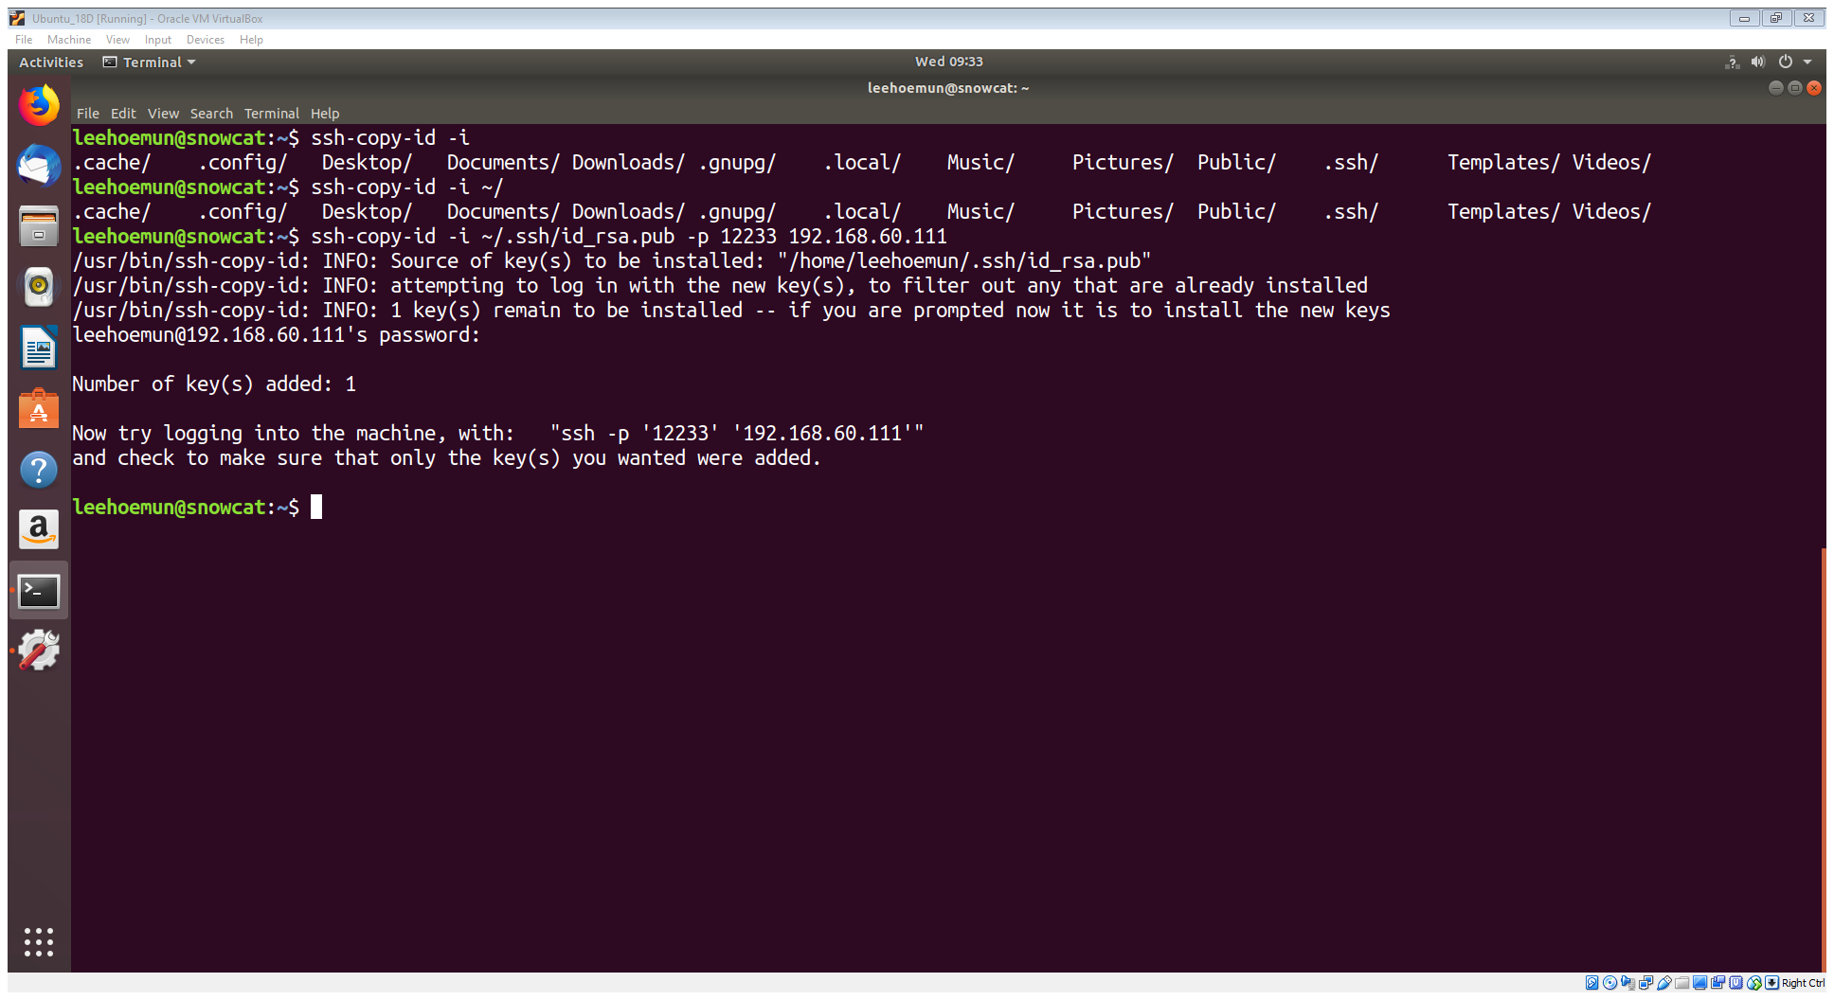 (1 mark)

1. Change the port number for **ssh** service to 12821.

Command: **nano /etc/ssh/sshd_config** (1 mark)

Screenshot of file content after changes: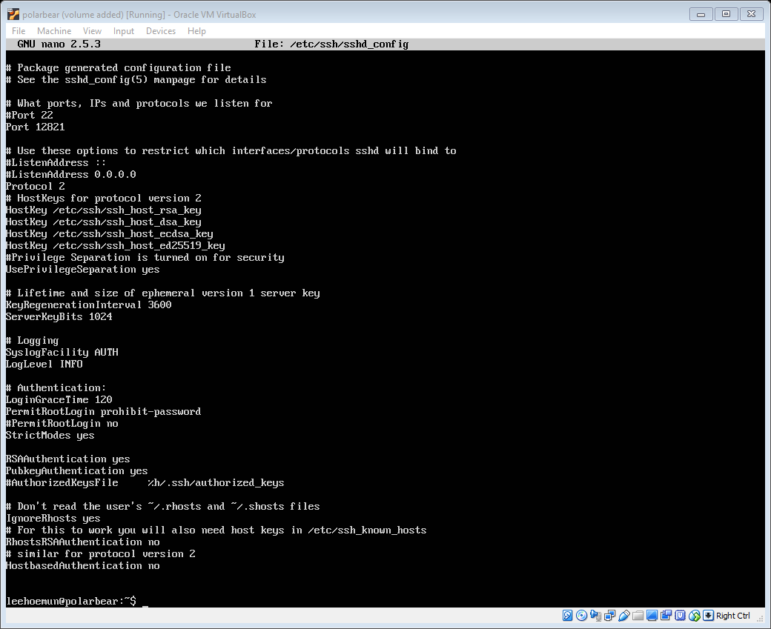 (1 mark)

1. Restart **ssh** service.

Command: **systemctl restart ssh.service** (1 mark)

Screenshot:

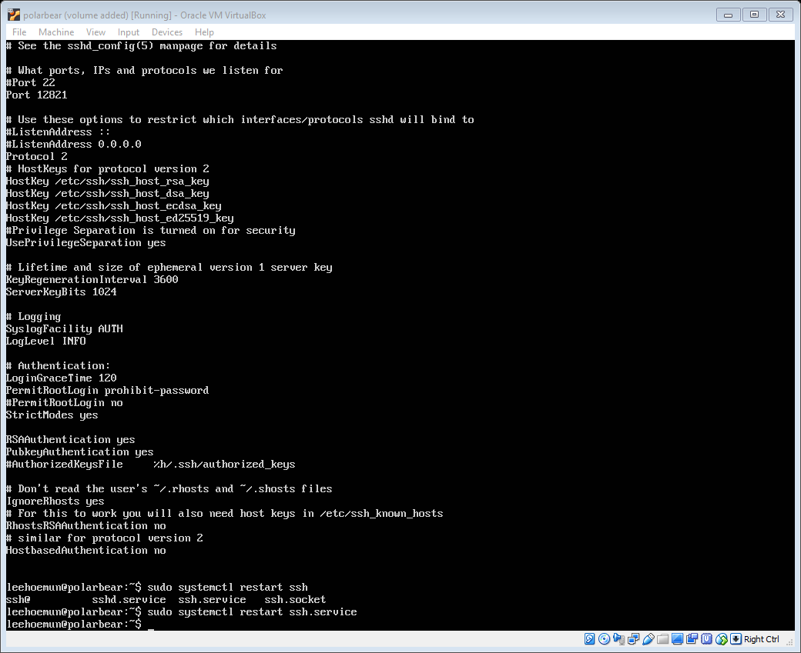 (1 mark)

1. Check if **ssh** is listening to the new port number.

Command: **netstat –putan | grep ssh** (2 marks)

Screenshot:

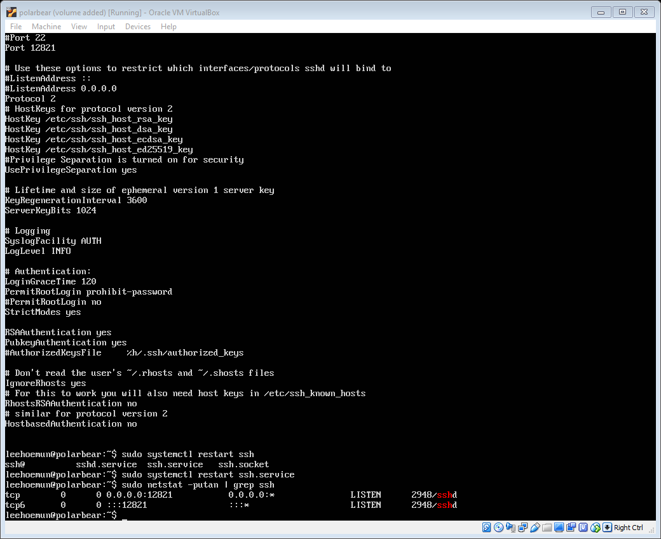 (1 mark)